**GROCERY MANAGEMENT SYSTEM**

**ABSTRACT**

**"Health is wealth”**. As the saying goes from our ancient times. Eat healthy and stay healthy as of now a days its very difficult to have healthy food. As pollution around the world has increased buying food on the road side is not advisable. Whether in charge of a small individually owned grocery store or one that is part of larger chain maintaining a grocery store successfully involves considerable responsibility. Grocery store managers must ensure that the store runs smoothly that items are priced comparatively and that customers are satisfied. Having a thorough understanding of key concepts involved in effective grocery store management is imperative for any manager dedicated to the success of his store. Particularly if the manages the small grocery store inventory requires more than simply keeping enough of every item in stock.

**INTRODUCTION**

A grocery store is a retail store that primarily sells food. A grocer is a bulk seller of food. Grocery stores often offer non-perishable food that is packaged in cans, bottles and boxes, with some also having fresh produce, butchers, delis, and bakeries. Large grocery stores that stock significant amounts of non-food products, such as clothing and household items, are called supermarkets. Some large supermarkets also include a pharmacy and an electronics section. As pollution around the world has increased buying food on the road side is not advisable. Whether in charge of a small individually owned grocery store or one that is part of larger chain maintaining a grocery store successfully involves considerable responsibility. Grocery store managers must ensure that the store runs smoothly that items are priced comparatively and that customers are satisfied. Having a thorough understanding of key concepts involved in effective grocery store management is imperative for any manager dedicated to the success of his store. Particularly if the manages the small grocery store inventory requires more than simply keeping enough of every item in stock.

**SYSTEM ANALYSIS**

**EXISTING SYSTEM:**

**DISADVANTAGES OF EXISTING SYSTEM:**

* Huge cost in terms of data usability. For example, the existing techniques on keyword-based information retrieval, which are widely used on the plaintext data, cannot be directly applied on the encrypted data. Downloading all the data from the cloud and decrypt locally is obviously impractical.
* Existing System methods not practical due to their high computational overhead for both the cloud sever and user.

**PROPOSED SYSTEM:**

* This paper proposes a secure tree-based search scheme over the encrypted cloud data, which supports multi-keyword ranked search and dynamic operation on the document collection. Specifically, the vector space model and the widely-used “term frequency (TF) *×* inverse document frequency (IDF)” model are combined in the index construction and query generation to provide multi-keyword ranked search. In order to obtain high search efficiency, we construct a tree-based index structure and propose a “Greedy Depth-first Search” algorithm based on this index tree.
* The secure kNN algorithm is utilized to encrypt the index and query vectors, and meanwhile ensure accurate relevance score calculation between encrypted index and query vectors.
* To resist different attacks in different threat models, we construct two secure search schemes: the basic dynamic multi-keyword ranked search (BDMRS) scheme in the known ciphertext model, and the enhanced dynamic multi-keyword ranked search (EDMRS) scheme in the known background model.

**ADVANTAGES OF PROPOSED SYSTEM:**

* Due to the special structure of our tree-based index, the proposed search scheme can flexibly achieve sub-linear search time and deal with the deletion and insertion of documents.
* We design a searchable encryption scheme that supports both the accurate multi-keyword ranked search and flexible dynamic operation on document collection.
* Due to the special structure of our tree-based index, the search complexity of the proposed scheme is fundamentally kept to logarithmic. And in practice, the proposed scheme can achieve higher search efficiency by executing our “Greedy Depth-first Search” algorithm. Moreover, parallel search can be flexibly performed to further reduce the time cost of search process.

**SYSTEM REQUIREMENTS:**

**HARDWARE REQUIREMENTS:**

* System : Pentium IV 2.4 GHz.
* Hard Disk : 40 GB.
* Floppy Drive : 1.44 Mb.
* Monitor : 15 VGA Colour.
* Mouse : Logitech.
* Ram : 512 Mb.

**SOFTWARE REQUIREMENTS:**

* Operating system : - Windows XP.
* Coding Language : J2EE
* Data Base : MYSQL

**IMPLEMENTATION**

**MODULES**

* Employee Module
* Administrater Module
* User Module
* Payment option Module

**MODULES DESCRIPTION**

**Employee Module:**

In this employee module the employee mainly receives the customers requirement and have to process on customers request.He makes the required changes as per the growth of the business.He bascially works on the available products and daily checks the stock availability on time and informs the administrative in charge about the products availability.He delivers the stock ordered by the customer with proper packing and in time delivery.He should check the product about the quality and quantity on how the products to be maintained.

**Administrator Module:**

In this administration of whole company is to be maintained.Supervision of employee and the requirement of business must be checked and required steps to be taken.The complaints and suggestions dropped by customers must be cheked and required steps are to be implemented.

**User Module:**

The user must have the personal account and using his login details customer first check the products availability and orders the required products. If the server is busy then customer has to retry once again and continue his request.He can check on various products availability and choose the products required.

**Payment option Module:**

We have to ways of payment options

* Pay now
* Cash on delivery

Customer can pay in two cases when he orders the stocks and after he receives the stock.We provide credits and debit card facility i.e on line banking system.We provide various bank payments.

**SYSTEM STUDY**

**FEASIBILITY STUDY**

The feasibility of the project is analyzed in this phase and business proposal is put forth with a very general plan for the project and some cost estimates. During system analysis the feasibility study of the proposed system is to be carried out. This is to ensure that the proposed system is not a burden to the company. For feasibility analysis, some understanding of the major requirements for the system is essential.

Three key considerations involved in the feasibility analysis are

* ECONOMICAL FEASIBILITY
* TECHNICAL FEASIBILITY
* SOCIAL FEASIBILITY

**ECONOMICAL FEASIBILITY**

This study is carried out to check the economic impact that the system will have on the organization. The amount of fund that the company can pour into the research and development of the system is limited. The expenditures must be justified. Thus the developed system as well within the budget and this was achieved because most of the technologies used are freely available. Only the customized products had to be purchased.

### TECHNICAL FEASIBILITY

This study is carried out to check the technical feasibility, that is, the technical requirements of the system. Any system developed must not have a high demand on the available technical resources. This will lead to high demands on the available technical resources. This will lead to high demands being placed on the client. The developed system must have a modest requirement, as only minimal or null changes are required for implementing this system.

**SOCIAL FEASIBILITY**

The aspect of study is to check the level of acceptance of the system by the user. This includes the process of training the user to use the system efficiently. The user must not feel threatened by the system, instead must accept it as a necessity. The level of acceptance by the users solely depends on the methods that are employed to educate the user about the system and to make him familiar with it. His level of confidence must be raised so that he is also able to make some constructive criticism, which is welcomed, as he is the final user of the system.

**`SCREEN SHOTS**

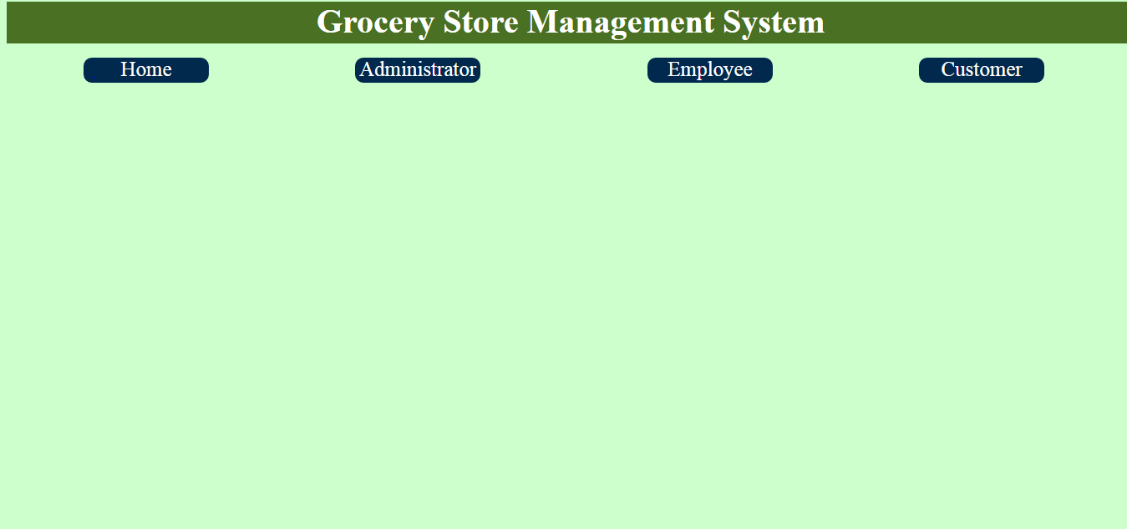

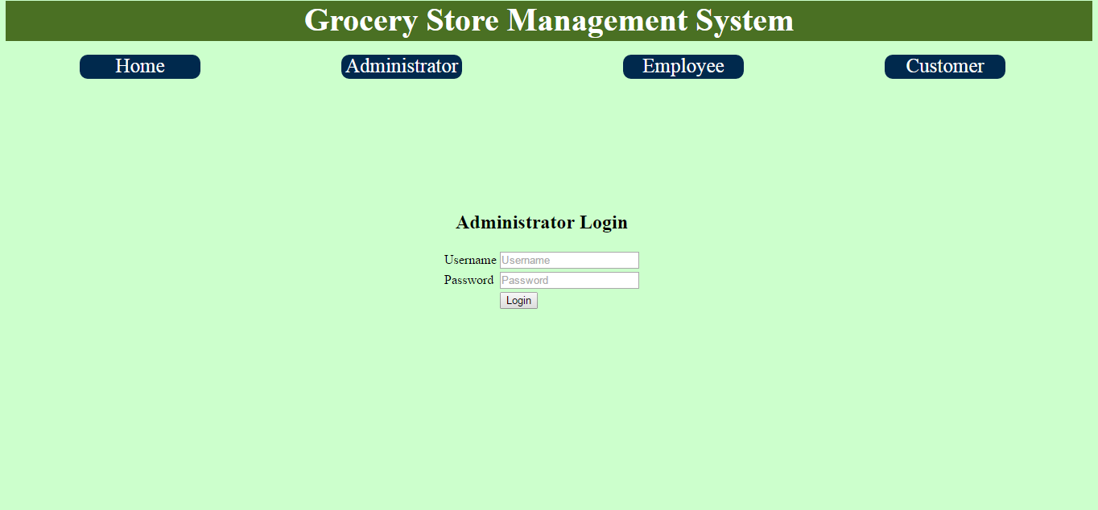

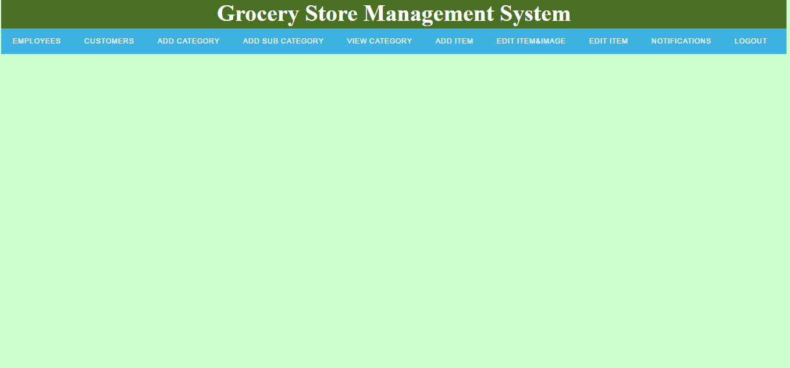

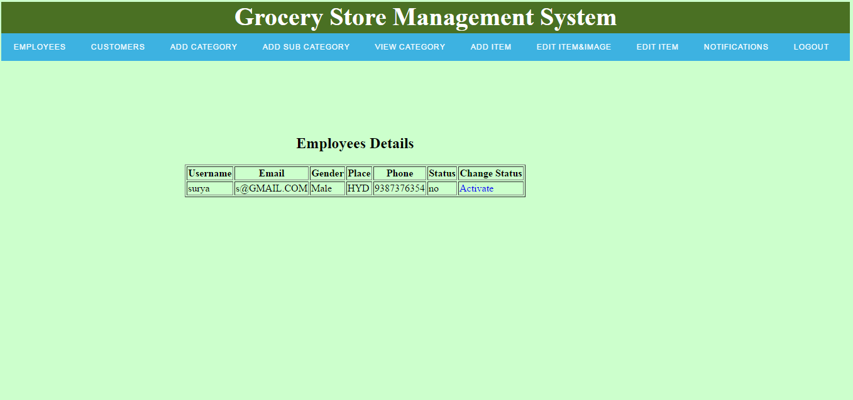

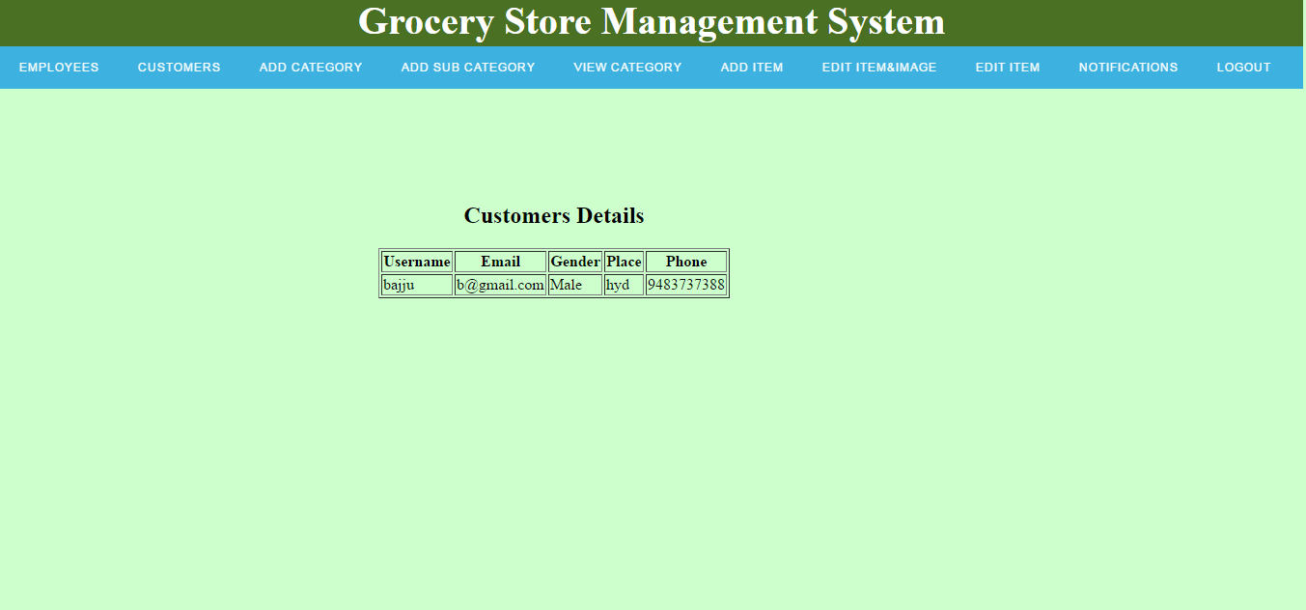

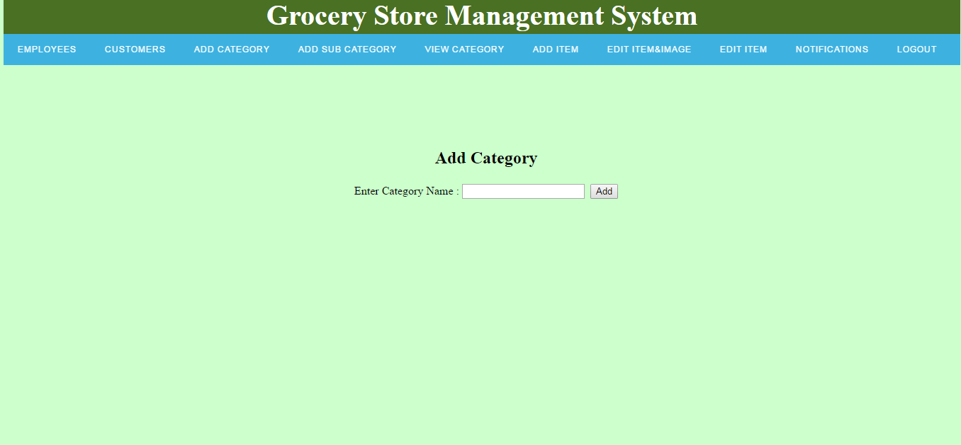

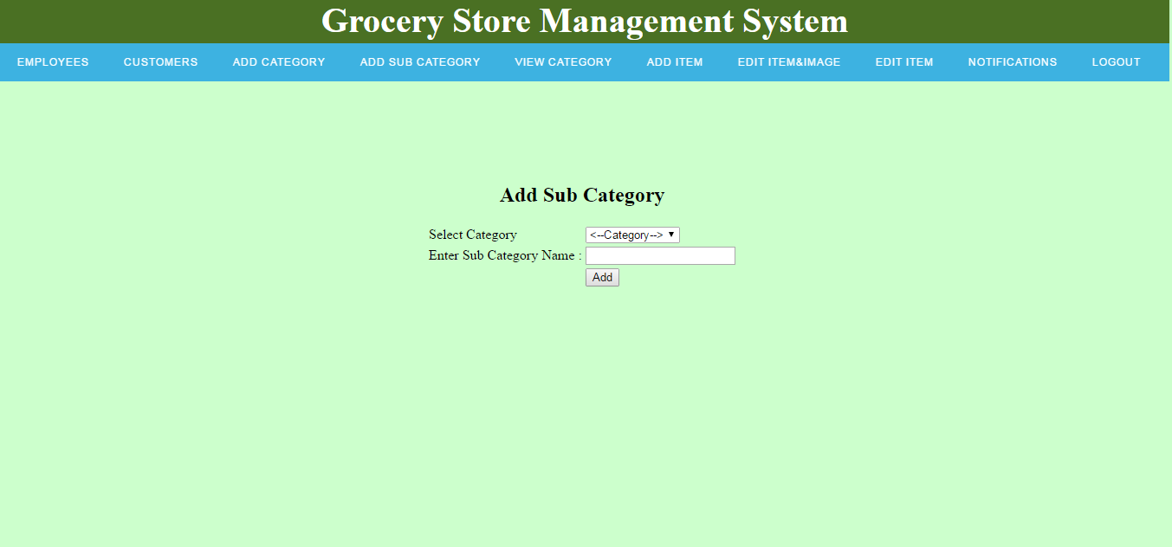

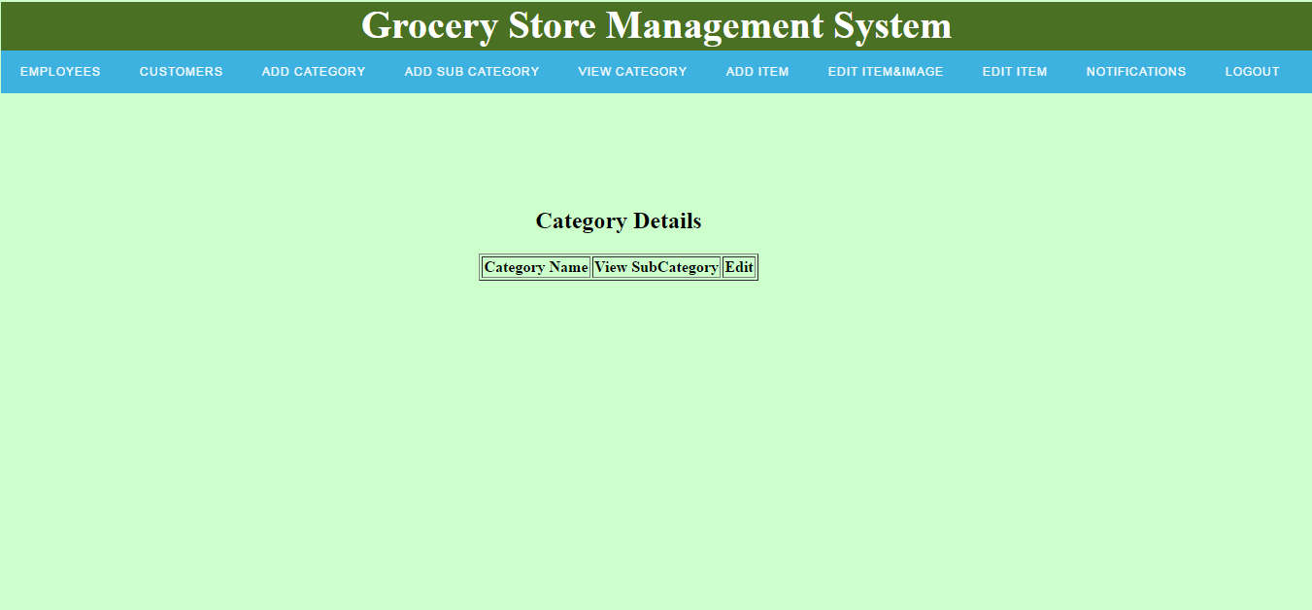

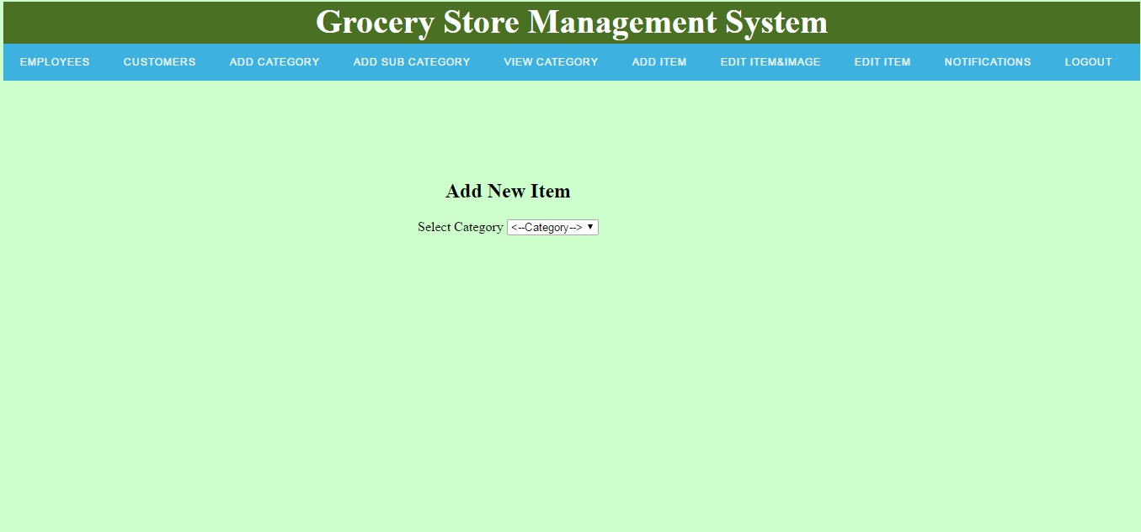

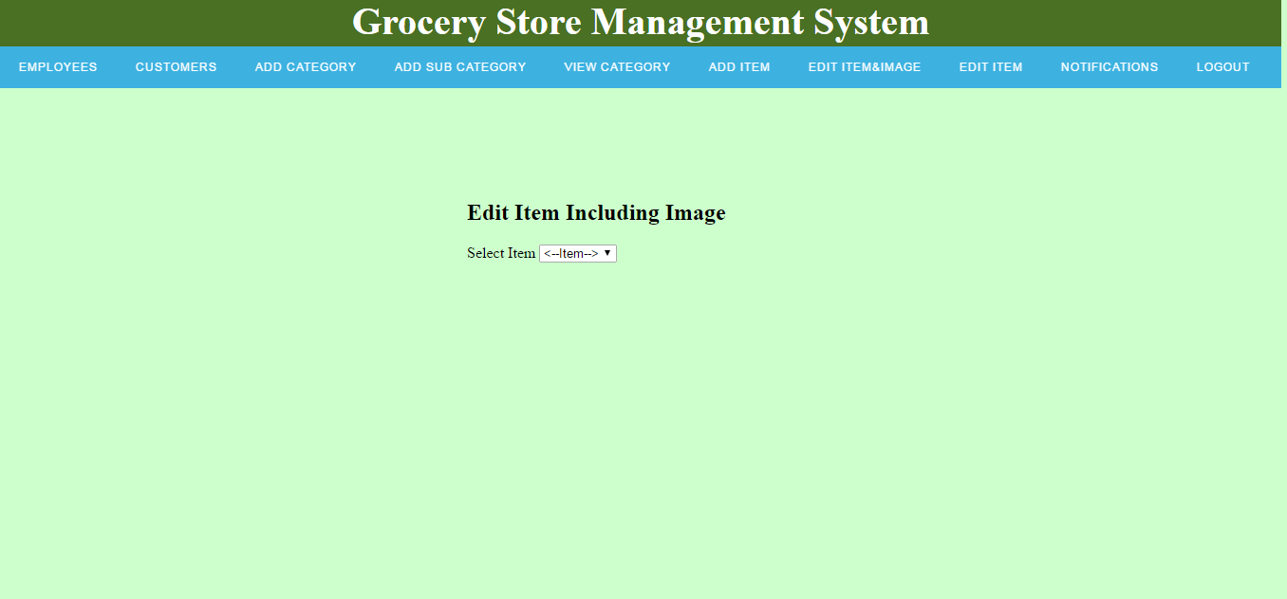

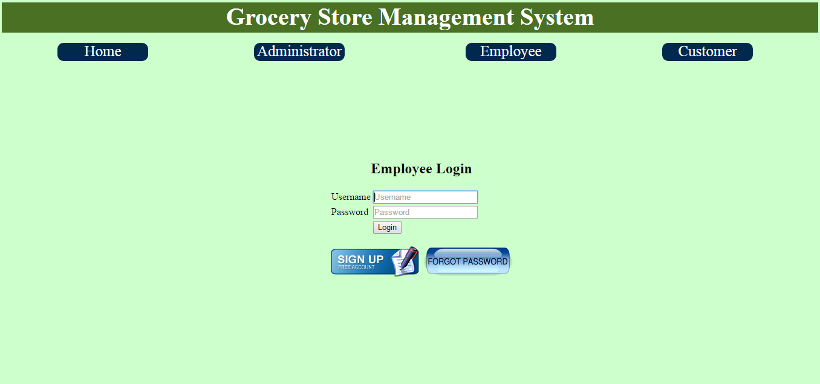

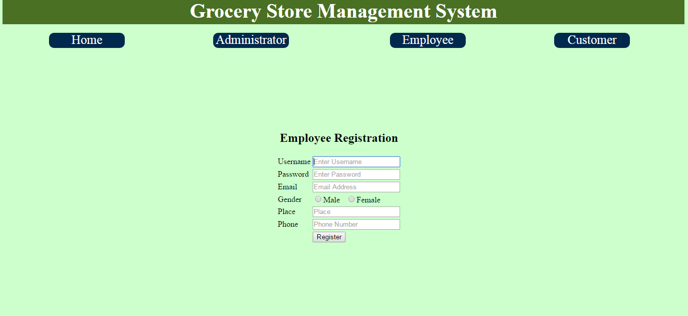

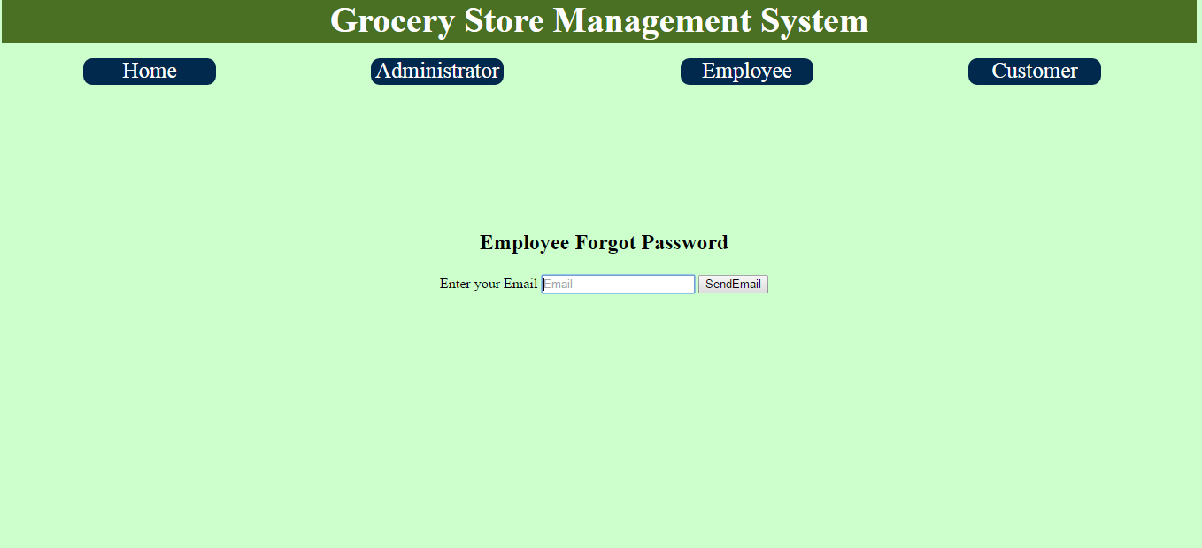

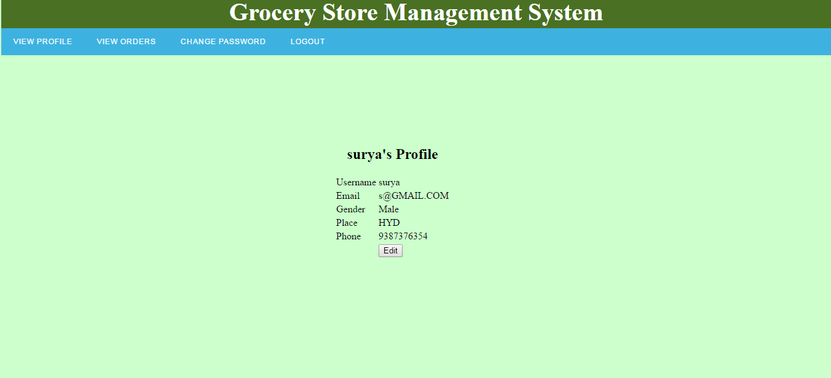

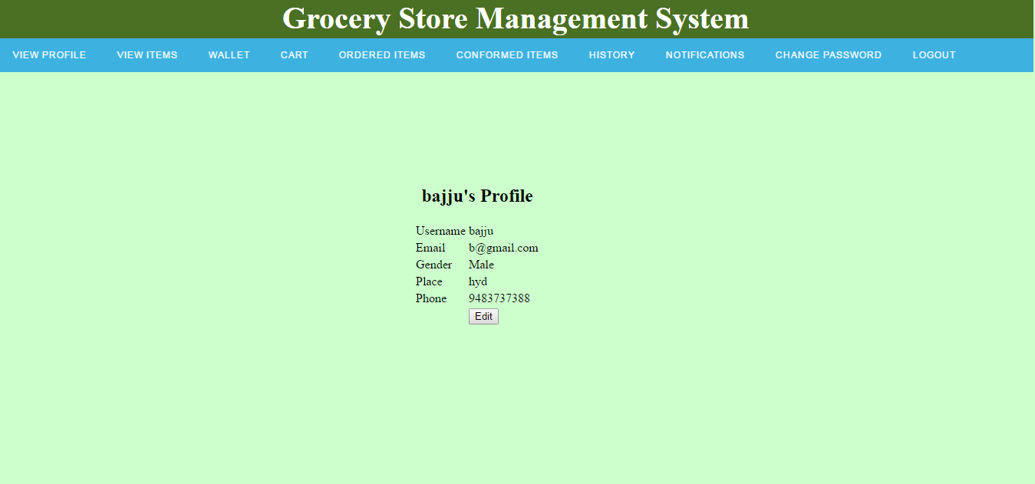

**SYSTEM DESIGN**

**SYSTEM ARCHITECTURE:**

**DATA FLOW DIAGRAM:**

1. The DFD is also called as bubble chart. It is a simple graphical formalism that can be used to represent a system in terms of input data to the system, various processing carried out on this data, and the output data is generated by this system.
2. The data flow diagram (DFD) is one of the most important modeling tools. It is used to model the system components. These components are the system process, the data used by the process, an external entity that interacts with the system and the information flows in the system.
3. DFD shows how the information moves through the system and how it is modified by a series of transformations. It is a graphical technique that depicts information flow and the transformations that are applied as data moves from input to output.
4. DFD is also known as bubble chart. A DFD may be used to represent a system at any level of abstraction. DFD may be partitioned into levels that represent increasing information flow and functional detail.

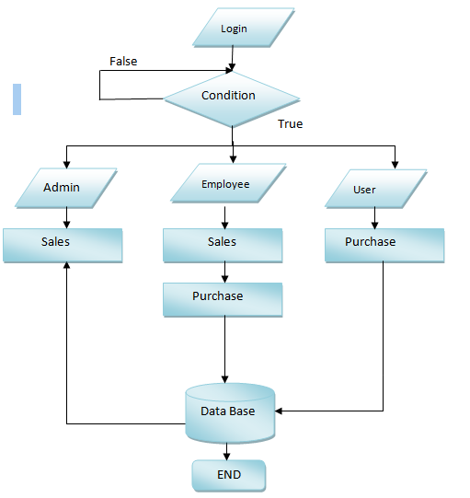

**UML DIAGRAMS**

UML stands for Unified Modeling Language. UML is a standardized general-purpose modeling language in the field of object-oriented software engineering. The standard is managed, and was created by, the Object Management Group.

The goal is for UML to become a common language for creating models of object oriented computer software. In its current form UML is comprised of two major components: a Meta-model and a notation. In the future, some form of method or process may also be added to; or associated with, UML.

The Unified Modeling Language is a standard language for specifying, Visualization, Constructing and documenting the artifacts of software system, as well as for business modeling and other non-software systems.

The UML represents a collection of best engineering practices that have proven successful in the modeling of large and complex systems.

The UML is a very important part of developing objects oriented software and the software development process. The UML uses mostly graphical notations to express the design of software projects.

**GOALS:**

The Primary goals in the design of the UML are as follows:

1. Provide users a ready-to-use, expressive visual modeling Language so that they can develop and exchange meaningful models.
2. Provide extendibility and specialization mechanisms to extend the core concepts.
3. Be independent of particular programming languages and development process.
4. Provide a formal basis for understanding the modeling language.
5. Encourage the growth of OO tools market.
6. Support higher level development concepts such as collaborations, frameworks, patterns and components.
7. Integrate best practices.

**USE CASE DIAGRAM:**

A use case diagram in the Unified Modeling Language (UML) is a type of behavioral diagram defined by and created from a Use-case analysis. Its purpose is to present a graphical overview of the functionality provided by a system in terms of actors, their goals (represented as use cases), and any dependencies between those use cases. The main purpose of a use case diagram is to show what system functions are performed for which actor. Roles of the actors in the system can be depicted.



**CLASS DIAGRAM:**

In software engineering, a class diagram in the Unified Modeling Language (UML) is a type of static structure diagram that describes the structure of a system by showing the system's classes, their attributes, operations (or methods), and the relationships among the classes. It explains which class contains information.



**SEQUENCE DIAGRAM:**

A sequence diagram in Unified Modeling Language (UML) is a kind of interaction diagram that shows how processes operate with one another and in what order. It is a construct of a Message Sequence Chart. Sequence diagrams are sometimes called event diagrams, event scenarios, and timing diagrams.



**ACTIVITY DIAGRAM:**

Activity diagrams are graphical representations of workflows of stepwise activities and actions with support for choice, iteration and concurrency. In the Unified Modeling Language, activity diagrams can be used to describe the business and operational step-by-step workflows of components in a system. An activity diagram shows the overall flow of control.

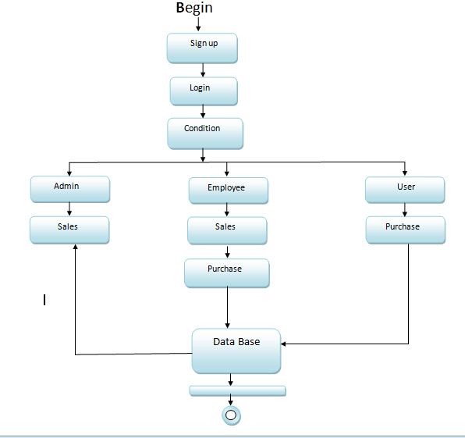

### SYSTEM TESTING

The purpose of testing is to discover errors. Testing is the process of trying to discover every conceivable fault or weakness in a work product. It provides a way to check the functionality of components, sub assemblies, assemblies and/or a finished product It is the process of exercising software with the intent of ensuring that the

Software system meets its requirements and user expectations and does not fail in an unacceptable manner. There are various types of test. Each test type addresses a specific testing requirement.

**TYPES OF TESTS**

**Unit testing**

Unit testing involves the design of test cases that validate that the internal program logic is functioning properly, and that program inputs produce valid outputs. All decision branches and internal code flow should be validated. It is the testing of individual software units of the application .it is done after the completion of an individual unit before integration. This is a structural testing, that relies on knowledge of its construction and is invasive. Unit tests perform basic tests at component level and test a specific business process, application, and/or system configuration. Unit tests ensure that each unique path of a business process performs accurately to the documented specifications and contains clearly defined inputs and expected results.

**Integration testing**

Integration tests are designed to test integrated software components to determine if they actually run as one program. Testing is event driven and is more concerned with the basic outcome of screens or fields. Integration tests demonstrate that although the components were individually satisfaction, as shown by successfully unit testing, the combination of components is correct and consistent. Integration testing is specifically aimed at exposing the problems that arise from the combination of components.

**Functional test**

Functional tests provide systematic demonstrations that functions tested are available as specified by the business and technical requirements, system documentation, and user manuals.

Functional testing is centered on the following items:

Valid Input : identified classes of valid input must be accepted.

Invalid Input : identified classes of invalid input must be rejected.

Functions : identified functions must be exercised.

Output : identified classes of application outputs must be exercised.

Systems/Procedures: interfacing systems or procedures must be invoked.

Organization and preparation of functional tests is focused on requirements, key functions, or special test cases. In addition, systematic coverage pertaining to identify Business process flows; data fields, predefined processes, and successive processes must be considered for testing. Before functional testing is complete, additional tests are identified and the effective value of current tests is determined.

**System Test**

System testing ensures that the entire integrated software system meets requirements. It tests a configuration to ensure known and predictable results. An example of system testing is the configuration oriented system integration test. System testing is based on process descriptions and flows, emphasizing pre-driven process links and integration points.

**White Box Testing**

White Box Testing is a testing in which in which the software tester has knowledge of the inner workings, structure and language of the software, or at least its purpose. It is purpose. It is used to test areas that cannot be reached from a black box level.

**Black Box Testing**

Black Box Testing is testing the software without any knowledge of the inner workings, structure or language of the module being tested. Black box tests, as most other kinds of tests, must be written from a definitive source document, such as specification or requirements document, such as specification or requirements document. It is a testing in which the software under test is treated, as a black box .you cannot “see” into it. The test provides inputs and responds to outputs without considering how the software works.

**6.1 Unit Testing:**

Unit testing is usually conducted as part of a combined code and unit test phase of the software lifecycle, although it is not uncommon for coding and unit testing to be conducted as two distinct phases.

**Test strategy and approach**

Field testing will be performed manually and functional tests will be written in detail.

**Test objectives**

* All field entries must work properly.
* Pages must be activated from the identified link.
* The entry screen, messages and responses must not be delayed.

**Features to be tested**

* Verify that the entries are of the correct format
* No duplicate entries should be allowed
* All links should take the user to the correct page.

# 6.2 Integration Testing

Software integration testing is the incremental integration testing of two or more integrated software components on a single platform to produce failures caused by interface defects.

The task of the integration test is to check that components or software applications, e.g. components in a software system or – one step up – software applications at the company level – interact without error.

**Test Results:** All the test cases mentioned above passed successfully. No defects encountered.

**6.3 Acceptance Testing**

User Acceptance Testing is a critical phase of any project and requires significant participation by the end user. It also ensures that the system meets the functional requirements.

**Test Results:** All the test cases mentioned above passed successfully. No defects encountered.

**Organization Profile**

**COMPANY PROFILE:**

Founded in 2009, HORNET located at DSNR, has a rich background in developing academic student projects, especially in solving latest IEEE Papers, Software Development and continues its entire attention on achieving transcending excellence in the Development and Maintenance of Software Projects and Products in Many Areas.

In Today's Modern Technological Competitive Environment, Students in Computer Science Stream Want To Ensure That They Are Getting Guidance In An Organization That Can Meet Their Professional Needs. With Our Well Equipped Team of Solid Information Systems Professionals, Who Study, Design, Develop, Enhance, Customize, Implement, Maintain and Support Various Aspects Of Information Technology, Students Can Be Sure.

We Understand The Students’ Needs, And Develop Their Quality Of Professional Life By Simply Making The Technology Readily Usable For Them. We Practice Exclusively in Software Development, Network Simulation, Search Engine Optimization, Customization And System Integration. Our Project Methodology Includes Techniques For Initiating A Project, Developing The Requirements, Making Clear Assignments To The Project Team, Developing A Dynamic Schedule, Reporting Status To Executives And Problem Solving.

The indispensable factors, which give the competitive advantages over others in the market, may be slated as:

* Performance
* Pioneering efforts
* Client satisfaction
* Innovative concepts
* Constant Evaluations
* Improvisation
* Cost Effectiveness

**About The People:**

As a team we have the clear vision and realize it too. As a statistical evaluation, the team has more than 40,000 hours of expertise in providing real-time solutions in the fields of Android Mobile Apps Development, Networking, Web Designing, Secure Computing, Mobile Computing, Cloud Computing, Image Processing And Implementation, Networking With OMNET++ Simulator, client Server Technologies in Java,(J2EE\J2ME\EJB), ANDROID, DOTNET (ASP.NET, VB.NET, C#.NET), MATLAB, NS2, SIMULINK, EMBEDDED, POWER ELECTRONICS, VB & VC++, Oracle and operating system concepts with LINUX.

**Our Vision:**

**“Impossible as Possible”** this is our vision; we work according to our vision.

**CONCLUSION**

By implimenting this grocery management system we are getting the more flexibility for the users can operate from the home itself by implementing the pay and pickup and pay now options so we are giving the flexibility for the user the communication also very easy so that we implemented our project inreal time we checked that our project is giving the more efficiency and flexibility and less communication cost and less compitational cost**.**Grocery store managers must ensure that the store runs smoothly that items are priced compitively and that customers are satisfied.Having a thorough understanding of key concepts involved in effective grocery store management is imperative for any manager dedicated to the success of his store.Particularly if the manages the small grocery store inventory requires more than simply keepin enough of every item in stock.